Laboratory classes

Introduction to ASP .NET Core

Overview of ASP.NET Core
ASP.NET Core is a cross-platform, high-performance, open-source framework for building modern, cloud-enabled, Internet-connected apps.
With ASP.NET Core, you can:
- Build web apps and services, Internet of Things (IoT) apps, and mobile backends.
- Use your favorite development tools on Windows, macOS, and Linux.
- Deploy to the cloud or on-premises.
- Run on .NET.
Why choose ASP.NET Core?
Millions of developers use or have used ASP.NET 4.x to create web apps. ASP.NET Core is a redesign of ASP.NET 4.x, including architectural changes that result in a leaner, more modular framework.
ASP.NET Core provides the following benefits:
- A unified story for building web UI and web APIs.
- Architected for testability.
- Razor Pages makes coding page-focused scenarios easier and more productive.
- Blazor lets you use C# in the browser alongside JavaScript. Share server-side and client-side app logic all written with .NET.
- Ability to develop and run on Windows, macOS, and Linux.
- Open-source and community-focused.
- Integration of modern, client-side frameworks and development workflows.
- Support for hosting Remote Procedure Call (RPC) services using gRPC.
- A cloud-ready, environment-based configuration system.
- Built-in dependency injection.
- A lightweight, high-performance, and modular HTTP request pipeline.
- Ability to host on the following:
  - Kestrel
  - IIS
  - HTTP.sys
  - Nginx
  - Apache
  - Docker
- Side-by-side versioning.
- Tooling that simplifies modern web development.
Build web APIs and web UI using ASP.NET Core MVC
ASP.NET Core MVC provides features to build web APIs and web apps:
- The Model-View-Controller (MVC) pattern helps make your web APIs and web apps testable.
- Razor Pages is a page-based programming model that makes building web UI easier and more productive.
- Razor markup provides a productive syntax for Razor Pages and MVC views.
- Tag Helpers enable server-side code to participate in creating and rendering HTML elements in Razor files.
- Built-in support for multiple data formats and content negotiation lets your web APIs reach a broad range of clients, including browsers and mobile devices.
- Model binding automatically maps data from HTTP requests to action method parameters.
- Model validation automatically performs client-side and server-side validation.
Client-side development
ASP.NET Core includes Blazor for building richly interactive web UI, and also integrates with other popular frontend JavaScript frameworks like Angular, React, Vue, and Bootstrap. For more information, see ASP.NET Core Blazor and related topics under Client-side development.
ASP.NET Core target frameworks
ASP.NET Core 3.x or later can only target .NET.
There are several advantages to targeting .NET, and these advantages increase with each release. Some advantages of .NET over .NET Framework include:
- Cross-platform. Runs on Windows, macOS, and Linux.
- Improved performance
- Side-by-side versioning
- New APIs
- Open source

Tutorial: Create a minimal API with ASP.NET Core
Minimal APIs are architected to create HTTP APIs with minimal dependencies. They're ideal for microservices and apps that want to include only the minimum files, features, and dependencies in ASP.NET Core.
This tutorial teaches the basics of building a minimal API with ASP.NET Core. Another approach to creating APIs in ASP.NET Core is to use controllers. For help with choosing between minimal APIs and controller-based APIs, see APIs overview. For a tutorial on creating an API project based on controllers that contains more features, see Create a web API.
Prerequisites
- Visual Studio 2022 with the ASP.NET and web development workload.
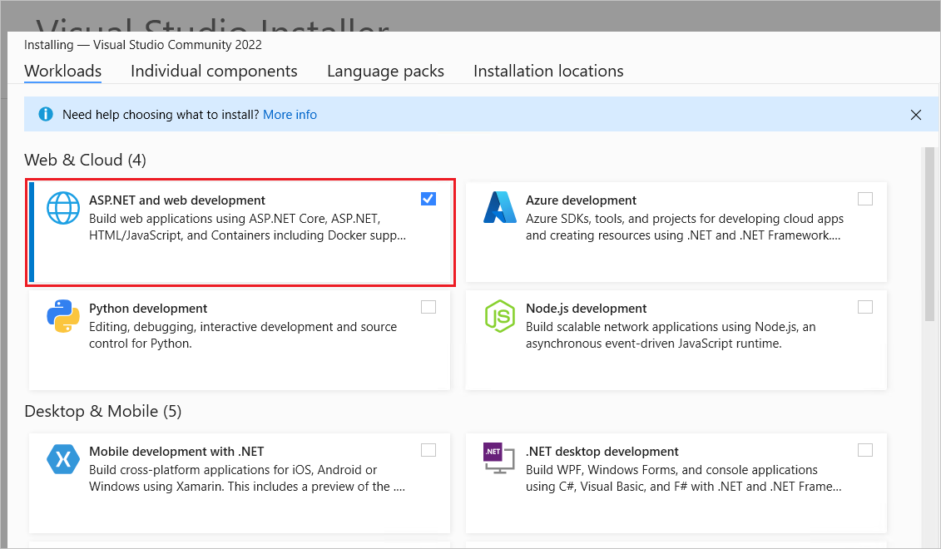
Create an API project
- Start Visual Studio 2022 and select Create a new project.
- In the Create a new project dialog:
  - Enter Empty in the Search for templates search box.
  - Select the ASP.NET Core Empty template and select Next.
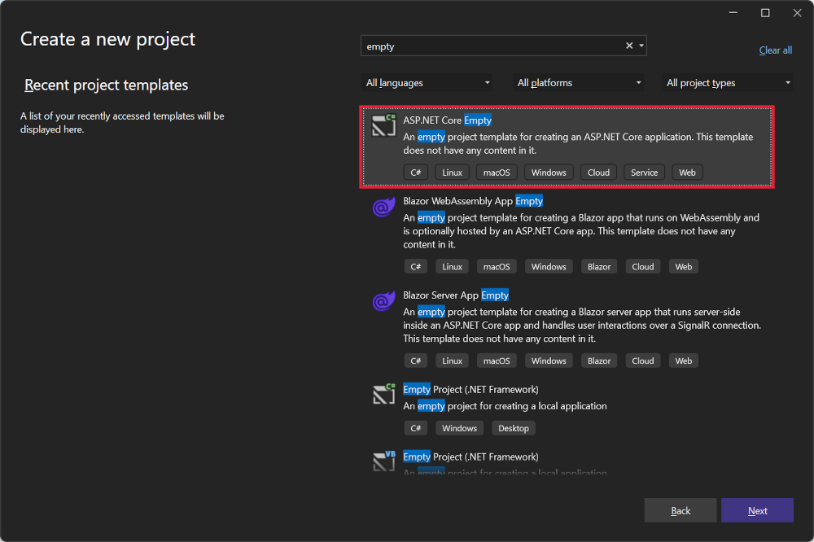
- Name the project TodoApi and select Next.
- In the Additional information dialog:
  - Select .NET 8.0 (Long Term Support)
  - Uncheck Do not use top-level statements
  - Select Create
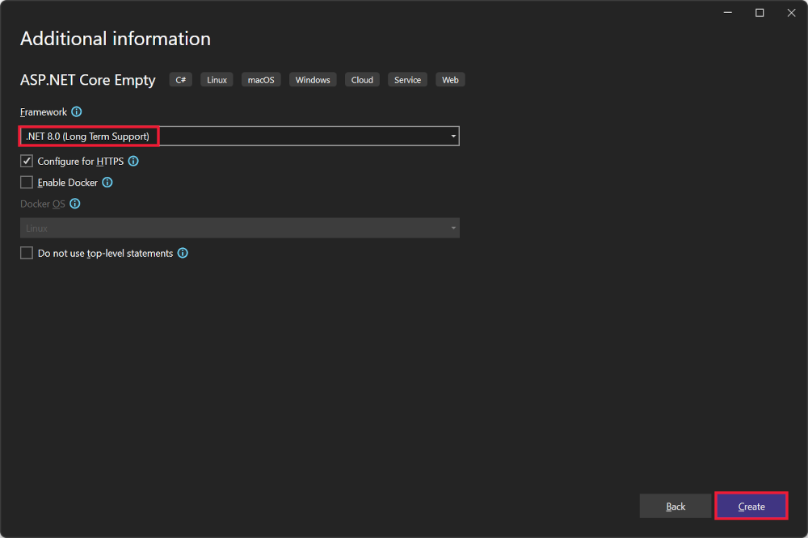
Examine the code
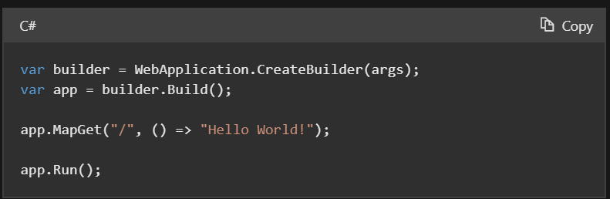
The preceding code:
- Creates a WebApplicationBuilder and a WebApplication with preconfigured defaults.
- Creates an HTTP GET endpoint / that returns Hello World!:
Run the app
Press Ctrl+F5 to run without the debugger.
Visual Studio displays the following dialog:
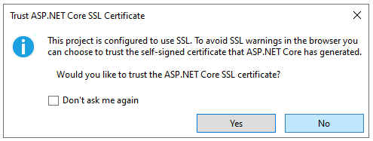
Select Yes if you trust the IIS Express SSL certificate.
The following dialog is displayed:
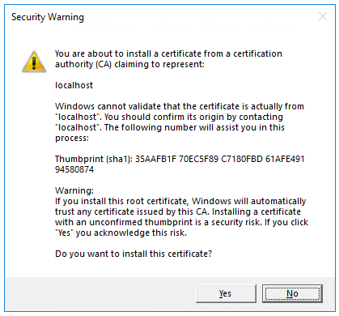
Select Yes if you agree to trust the development certificate.
For information on trusting the Firefox browser, see Firefox SEC_ERROR_INADEQUATE_KEY_USAGE certificate error.
Visual Studio launches the Kestrel web server and opens a browser window.
Hello World! is displayed in the browser. The Program.cs file contains a minimal but complete app.
Close the browser window.
The model and classes
- In the project folder, create a file named Todo.cs with the following code:
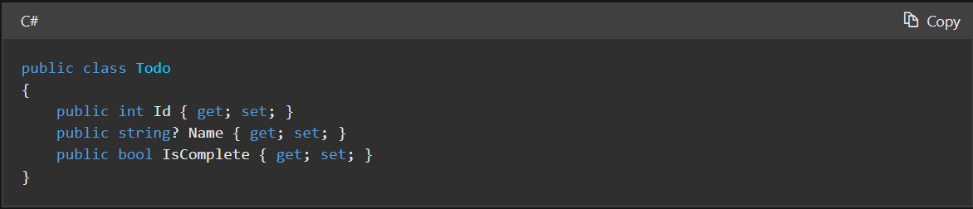

Controllers

ASP.NET Core supports creating web APIs using controllers or using minimal APIs. Controllers in a web API are classes that derive from ControllerBase. Controllers are activated and disposed on a per request basis.
This article shows how to use controllers for handling web API requests. For information on creating web APIs without controllers, see Tutorial: Create a minimal API with ASP.NET Core.
ControllerBase class
A controller-based web API consists of one or more controller classes that derive from ControllerBase. The web API project template provides a starter controller:
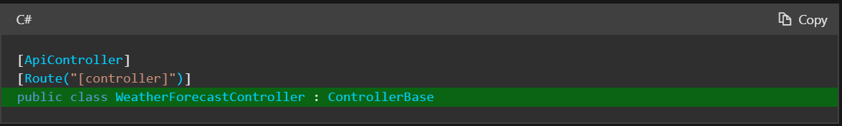
Web API controllers should typically derive from ControllerBase rather from Controller. Controller derives from ControllerBase and adds support for views, so it's for handling web pages, not web API requests. If the same controller must support views and web APIs, derive from Controller.
The ControllerBase class provides many properties and methods that are useful for handling HTTP requests. For example, CreatedAtAction returns a 201 status code:
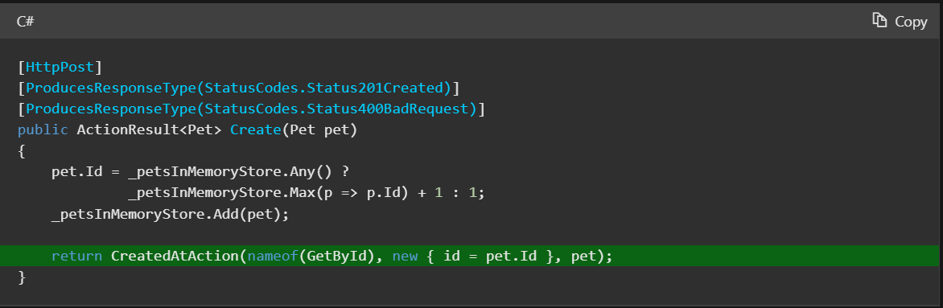The following table contains examples of methods in ControllerBase.

Method | Notes
BadRequest | Returns 400 status code.
NotFound | Returns 404 status code.
PhysicalFile | Returns a file.
TryUpdateModelAsync | Invokes model binding.
TryValidateModel | Invokes model validation.
For a list of all available methods and properties, see ControllerBase.
Attributes
The Microsoft.AspNetCore.Mvc namespace provides attributes that can be used to configure the behavior of web API controllers and action methods. The following example uses attributes to specify the supported HTTP action verb and any known HTTP status codes that could be returned:
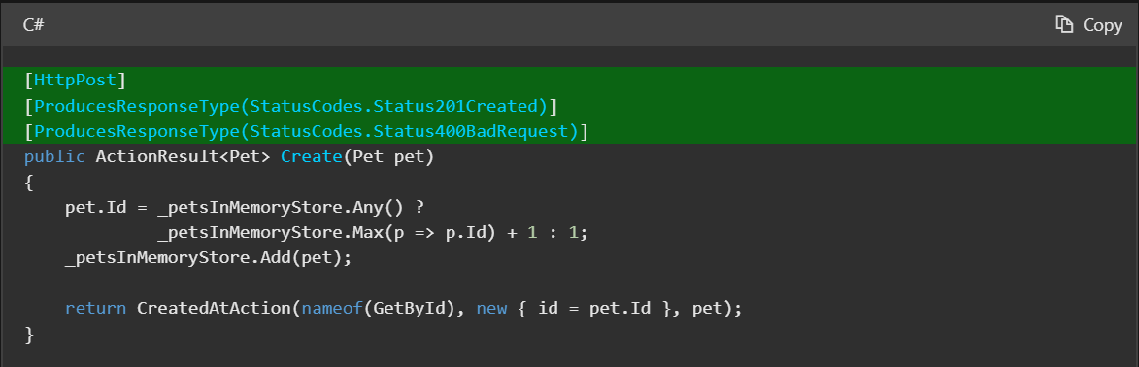
Here are some more examples of attributes that are available.
Expand table
Attribute | Notes
[Route] | Specifies URL pattern for a controller or action.
[Bind] | Specifies prefix and properties to include for model binding.
[HttpGet] | Identifies an action that supports the HTTP GET action verb.
[Consumes] | Specifies data types that an action accepts.
[Produces] | Specifies data types that an action returns.
For a list that includes the available attributes, see the Microsoft.AspNetCore.Mvc namespace.
ApiController attribute
The [ApiController] attribute can be applied to a controller class to enable the following opinionated, API-specific behaviors:
- Attribute routing requirement
- Automatic HTTP 400 responses
- Binding source parameter inference
- Multipart/form-data request inference
- Problem details for error status codes
Attribute on specific controllers
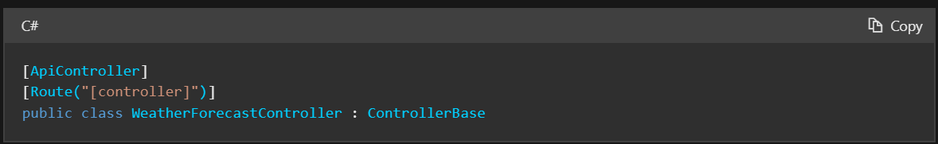
Attribute on multiple controllers
One approach to using the attribute on more than one controller is to create a custom base controller class annotated with the [ApiController] attribute. The following example shows a custom base class and a controller that derives from it:
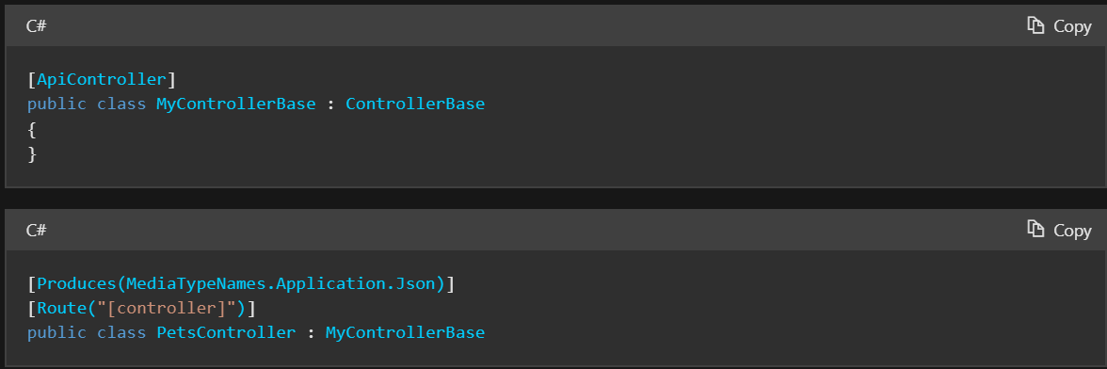

There are three main components to Swashbuckle:
- Swashbuckle.AspNetCore.Swagger: a Swagger object model and middleware to expose SwaggerDocument objects as JSON endpoints.
- Swashbuckle.AspNetCore.SwaggerGen: a Swagger generator that builds SwaggerDocument objects directly from your routes, controllers, and models. It's typically combined with the Swagger endpoint middleware to automatically expose Swagger JSON.
- Swashbuckle.AspNetCore.SwaggerUI: an embedded version of the Swagger UI tool. It interprets Swagger JSON to build a rich, customizable experience for describing the web API functionality. It includes built-in test harnesses for the public methods.

Package installation
Swashbuckle can be added with the following approaches:
- From the Package Manager Console window:
  - Go to View > Other Windows > Package Manager Console
  - Navigate to the directory in which the .csproj file exists
  - Execute the following command:
PowerShellCopy
Install-Package Swashbuckle.AspNetCore -Version 6.5.0
- From the Manage NuGet Packages dialog:
  - Right-click the project in Solution Explorer > Manage NuGet Packages
  - Set the Package source to "nuget.org"
  - Ensure the "Include prerelease" option is enabled
  - Enter "Swashbuckle.AspNetCore" in the search box
  - Select the latest "Swashbuckle.AspNetCore" package from the Browse tab and click Install
Add and configure Swagger middleware
Add the Swagger generator to the services collection in Program.cs:
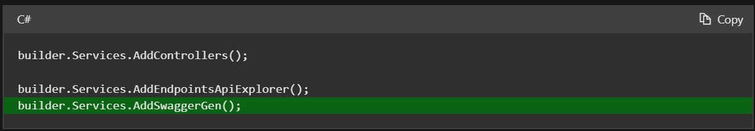 The call to AddEndpointsApiExplorer shown in the preceding example is required only for minimal APIs. For more information, see this StackOverflow post.
Enable the middleware for serving the generated JSON document and the Swagger UI, also in Program.cs:
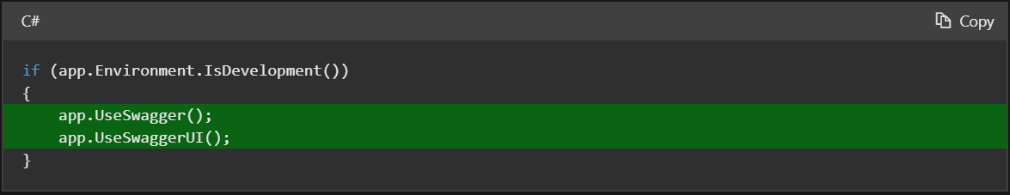
The preceding code adds the Swagger middleware only if the current environment is set to Development. The UseSwaggerUI method call enables an embedded version of the Swagger UI tool.
Launch the app and navigate to https://localhost:<port>/swagger/v1/swagger.json. The generated document describing the endpoints appears as shown in OpenAPI specification (openapi.json).
The Swagger UI can be found at https://localhost:<port>/swagger. Explore the API via Swagger UI and incorporate it in other programs.
Tip
To serve the Swagger UI at the app's root (https://localhost:<port>/), set the RoutePrefix property to an empty string:
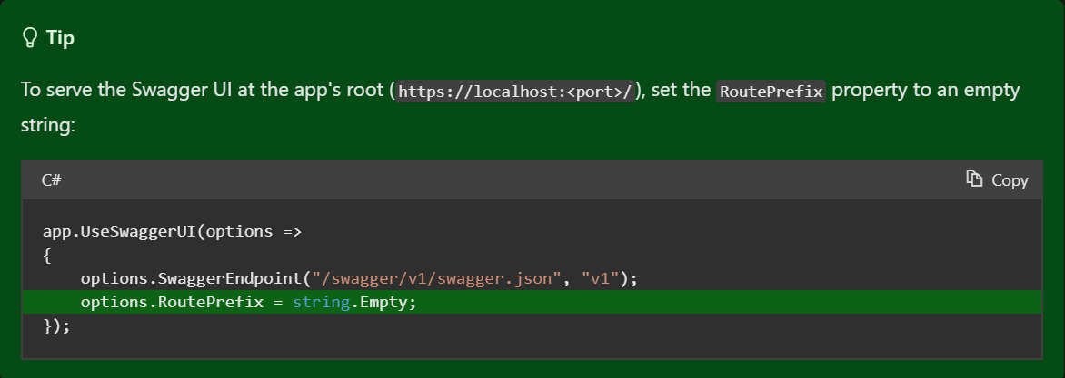 If using directories with IIS or a reverse proxy, set the Swagger endpoint to a relative path using the ./ prefix. For example, ./swagger/v1/swagger.json. Using /swagger/v1/swagger.json instructs the app to look for the JSON file at the true root of the URL (plus the route prefix, if used). For example, use https://localhost:<port>/<route_prefix>/swagger/v1/swagger.json instead of https://localhost:<port>/<virtual_directory>/<route_prefix>/swagger/v1/swagger.json.

Routing

Routing is responsible for matching incoming HTTP requests and dispatching those requests to the app's executable endpoints. Endpoints are the app's units of executable request-handling code. Endpoints are defined in the app and configured when the app starts. The endpoint matching process can extract values from the request's URL and provide those values for request processing. Using endpoint information from the app, routing is also able to generate URLs that map to endpoints.

Routing basics
The following code shows a basic example of routing:
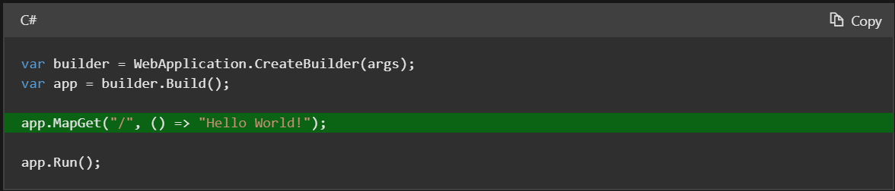

The preceding example includes a single endpoint using the MapGet method:
- When an HTTP GET request is sent to the root URL /:
  - The request delegate executes.
  - Hello World! is written to the HTTP response.
- If the request method is not GET or the root URL is not /, no route matches and an HTTP 404 is returned.
Routing uses a pair of middleware, registered by UseRouting and UseEndpoints:
- UseRouting adds route matching to the middleware pipeline. This middleware looks at the set of endpoints defined in the app, and selects the best match based on the request.
- UseEndpoints adds endpoint execution to the middleware pipeline. It runs the delegate associated with the selected endpoint.
Apps typically don't need to call UseRouting or UseEndpoints. WebApplicationBuilder configures a middleware pipeline that wraps middleware added in Program.cs with UseRouting and UseEndpoints. However, apps can change the order in which UseRouting and UseEndpoints run by calling these methods explicitly. For example, the following code makes an explicit call to UseRouting:
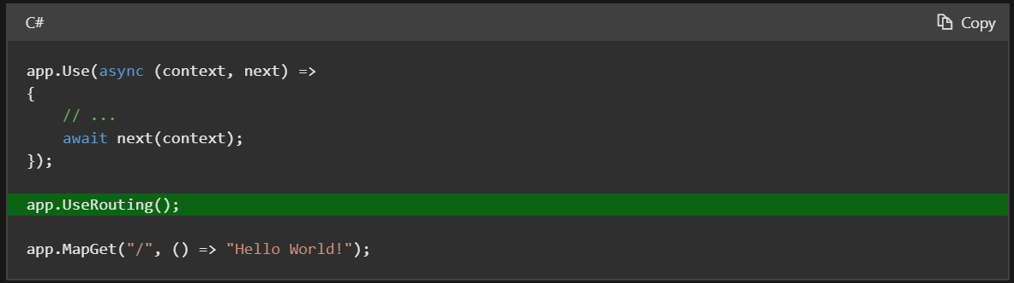

In the preceding code:
- The call to app.Use registers a custom middleware that runs at the start of the pipeline.
- The call to UseRouting configures the route matching middleware to run after the custom middleware.
- The endpoint registered with MapGet runs at the end of the pipeline.
If the preceding example didn't include a call to UseRouting, the custom middleware would run after the route matching middleware.
Note: Routes added directly to the WebApplication execute at the end of the pipeline.

ASP.NET Core controllers use the Routing middleware to match the URLs of incoming requests and map them to actions. Route templates:
- Are defined at startup in Program.cs or in attributes.
- Describe how URL paths are matched to actions.
- Are used to generate URLs for links. The generated links are typically returned in responses.
Actions are either conventionally-routed or attribute-routed. Placing a route on the controller or action makes it attribute-routed. See Mixed routing for more information.
This document:
- Explains the interactions between MVC and routing:
  - How typical MVC apps make use of routing features.
  - Covers both:
    - Conventional routing typically used with controllers and views.
    - Attribute routing used with REST APIs. If you're primarily interested in routing for REST APIs, jump to the Attribute routing for REST APIs section.
  - See Routing for advanced routing details.
- Refers to the default routing system called endpoint routing. It's possible to use controllers with the previous version of routing for compatibility purposes. See the 2.2-3.0 migration guide for instructions.
Set up conventional route
The ASP.NET Core MVC template generates conventional routing code similar to the following:
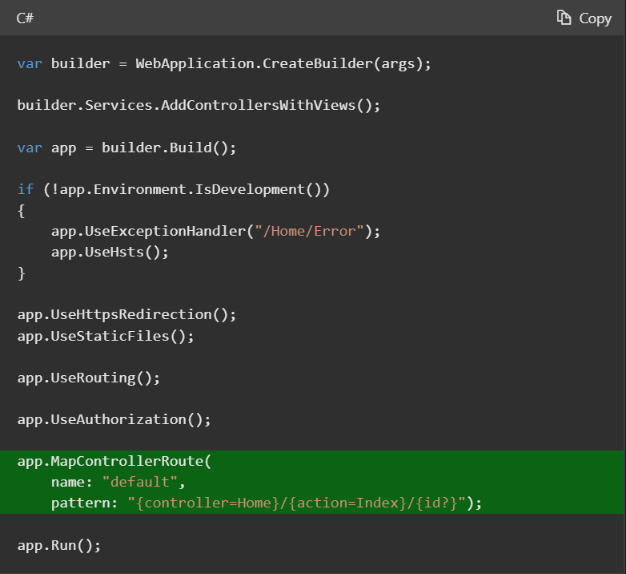
MapControllerRoute is used to create a single route. The single route is named default route. Most apps with controllers and views use a route template similar to the default route. REST APIs should use attribute routing.
Attribute routing uses a set of attributes to map actions directly to route templates. The following code is typical for a REST API and is used in the next sample:
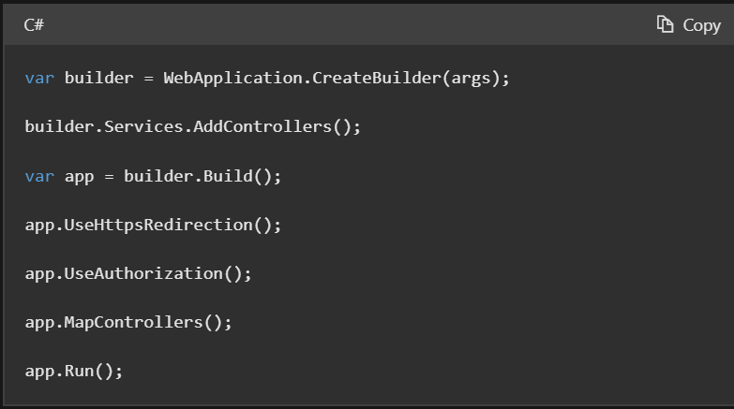
In the preceding code, MapControllers is called to map attribute routed controllers.
In the following example:
- HomeController matches a set of URLs similar to what the default conventional route {controller=Home}/{action=Index}/{id?} matches.
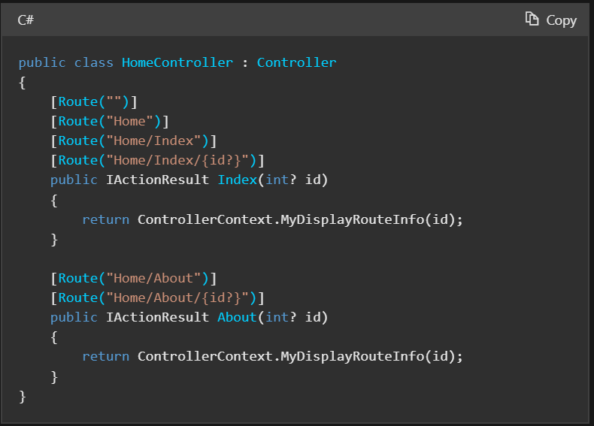
The HomeController.Index action is run for any of the URL paths /, /Home, /Home/Index, or /Home/Index/3.
This example highlights a key programming difference between attribute routing and conventional routing. Attribute routing requires more input to specify a route. The conventional default route handles routes more succinctly. However, attribute routing allows and requires precise control of which route templates apply to each action.
With attribute routing, the controller and action names play no part in which action is matched, unless token replacement is used. The following example matches the same URLs as the previous example:
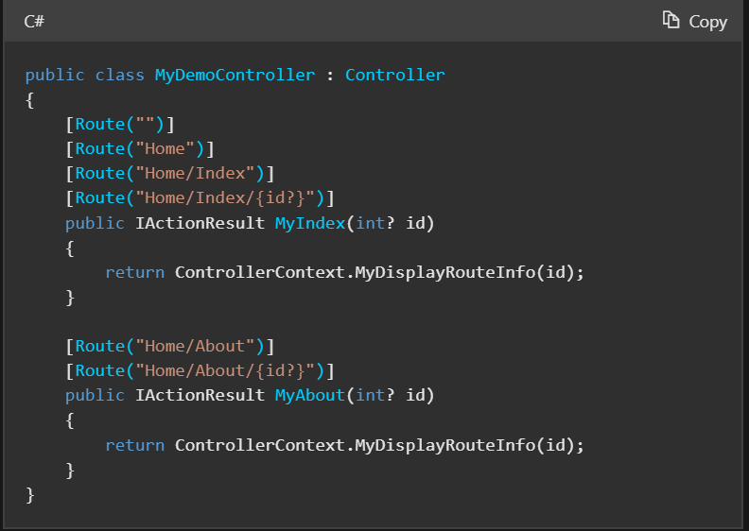
Reserved routing names
The following keywords are reserved route parameter names when using Controllers or Razor Pages:
- action
- area
- controller
- handler
- page
Using page as a route parameter with attribute routing is a common error. Doing that results in inconsistent and confusing behavior with URL generation.
Attribute routing with Http verb attributes
Consider the following controller:
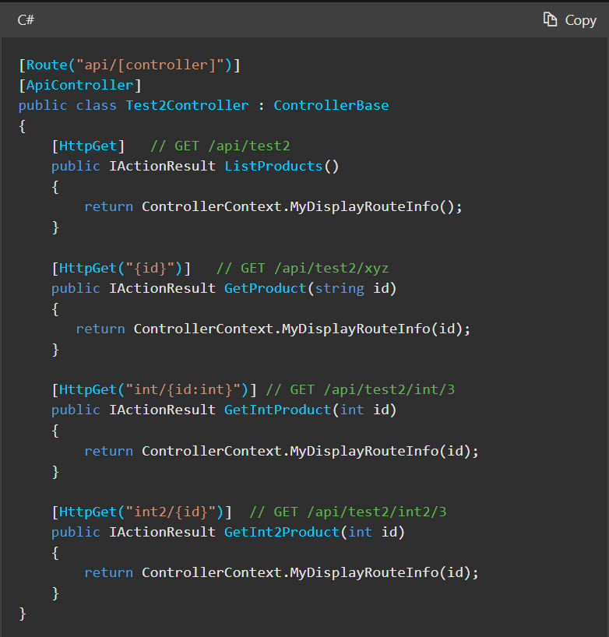
In the preceding code:
- Each action contains the [HttpGet] attribute, which constrains matching to HTTP GET requests only.
- The GetProduct action includes the "{id}" template, therefore id is appended to the "api/[controller]" template on the controller. The methods template is "api/[controller]/{id}". Therefore this action only matches GET requests for the form /api/test2/xyz,/api/test2/123,/api/test2/{any string}, etc.

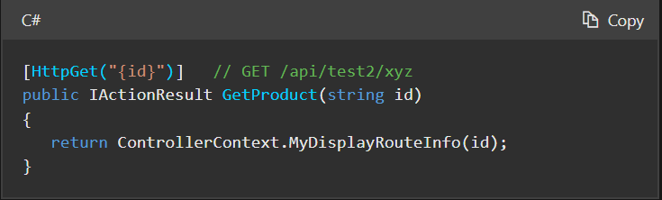
The GetIntProduct action contains the "int/{id:int}" template. The :int portion of the template constrains the id route values to strings that can be converted to an integer. A GET request to /api/test2/int/abc:
- Doesn't match this action.
- Returns a 404 Not Found error.
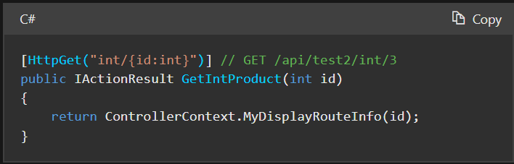
The GetInt2Product action contains {id} in the template, but doesn't constrain id to values that can be converted to an integer. A GET request to /api/test2/int2/abc:
- Matches this route.
- Model binding fails to convert abc to an integer. The id parameter of the method is integer.
- Returns a 400 Bad Request because model binding failed to convert abc to an integer.
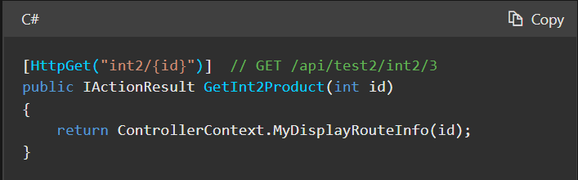
Attribute routing can use HttpMethodAttribute attributes such as HttpPostAttribute, HttpPutAttribute, and HttpDeleteAttribute. All of the HTTP verb attributes accept a route template. The following example shows two actions that match the same route template:
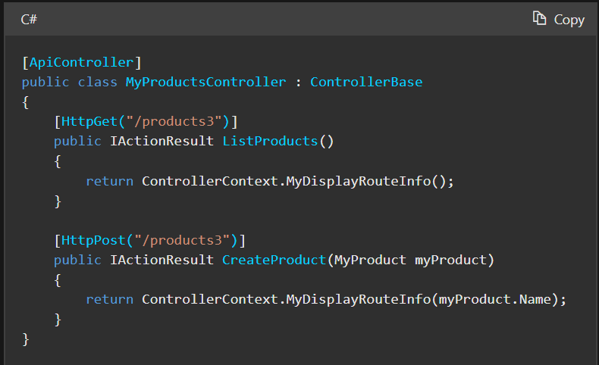
Using the URL path /products3:
- The MyProductsController.ListProducts action runs when the HTTP verb is GET.
- The MyProductsController.CreateProduct action runs when the HTTP verb is POST.
When building a REST API, it's rare that you'll need to use [Route(...)] on an action method because the action accepts all HTTP methods. It's better to use the more specific HTTP verb attribute to be precise about what your API supports. Clients of REST APIs are expected to know what paths and HTTP verbs map to specific logical operations.
REST APIs should use attribute routing to model the app's functionality as a set of resources where operations are represented by HTTP verbs. This means that many operations, for example, GET and POST on the same logical resource use the same URL. Attribute routing provides a level of control that's needed to carefully design an API's public endpoint layout.
Since an attribute route applies to a specific action, it's easy to make parameters required as part of the route template definition. In the following example, id is required as part of the URL path:
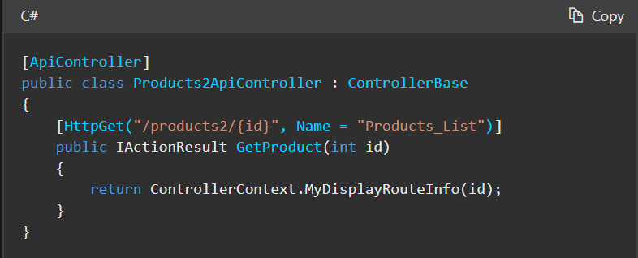

More details about routing can be found here https://learn.microsoft.com/en-us/aspnet/core/mvc/controllers/routing?view=aspnetcore-8.0#ar6

Configuration

Application configuration in ASP.NET Core is performed using one or more configuration providers. Configuration providers read configuration data from key-value pairs using a variety of configuration sources:
- Settings files, such as appsettings.json
- Environment variables
- Azure Key Vault
- Azure App Configuration
- Command-line arguments
- Custom providers, installed or created
- Directory files
- In-memory .NET objects
This article provides information on configuration in ASP.NET Core. For information on using configuration in console apps, see .NET Configuration.
Application and Host Configuration
ASP.NET Core apps configure and launch a host. The host is responsible for app startup and lifetime management. The ASP.NET Core templates create a WebApplicationBuilder which contains the host. While some configuration can be done in both the host and the application configuration providers, generally, only configuration that is necessary for the host should be done in host configuration.
Application configuration is the highest priority and is detailed in the next section. Host configuration follows application configuration, and is described in this article.
Default application configuration sources
ASP.NET Core web apps created with dotnet new or Visual Studio generate the following code:
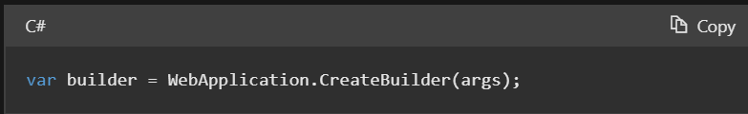

WebApplication.CreateBuilder initializes a new instance of the WebApplicationBuilder class with preconfigured defaults. The initialized WebApplicationBuilder (builder) provides default configuration for the app in the following order, from highest to lowest priority:
- Command-line arguments using the Command-line configuration provider.
- Non-prefixed environment variables using the Non-prefixed environment variables configuration provider.
- User secrets when the app runs in the Development environment.
- appsettings.{Environment}.json using the JSON configuration provider. For example, appsettings.Production.json and appsettings.Development.json.
- appsettings.json using the JSON configuration provider.
- A fallback to the host configuration described in the next section.
Default host configuration sources
The following list contains the default host configuration sources from highest to lowest priority for WebApplicationBuilder:
- Command-line arguments using the Command-line configuration provider
- DOTNET_-prefixed environment variables using the Environment variables configuration provider.
- ASPNETCORE_-prefixed environment variables using the Environment variables configuration provider.
For the .NET Generic Host and Web Host, the default host configuration sources from highest to lowest priority is:
- ASPNETCORE_-prefixed environment variables using the Environment variables configuration provider.
- Command-line arguments using the Command-line configuration provider
- DOTNET_-prefixed environment variables using the Environment variables configuration provider.
When a configuration value is set in host and application configuration, the application configuration is used.
Host variables
The following variables are locked in early when initializing the host builders and can't be influenced by application config:
- Application name
- Environment name, for example Development, Production, and Staging
- Content root
- Web root
- Whether to scan for hosting startup assemblies and which assemblies to scan for.
- Variables read by app and library code from HostBuilderContext.Configuration in IHostBuilder.ConfigureAppConfiguration callbacks.
Every other host setting is read from application config instead of host config.
URLS is one of the many common host settings that is not a bootstrap setting. Like every other host setting not in the previous list, URLS is read later from application config. Host config is a fallback for application config, so host config can be used to set URLS, but it will be overridden by any configuration source in application config like appsettings.json.
For more information, see Change the content root, app name, and environment and Change the content root, app name, and environment by environment variables or command line
The remaining sections in this article refer to application configuration.
Application configuration providers
The following code displays the enabled configuration providers in the order they were added:
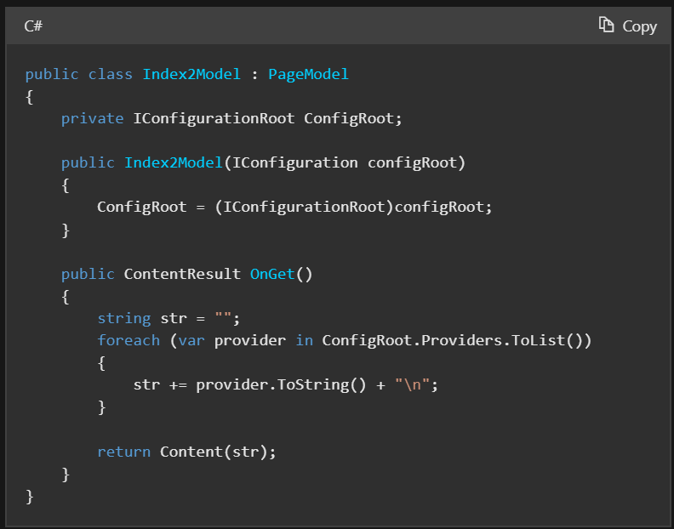
The preceding list of highest to lowest priority default configuration sources shows the providers in the opposite order they are added to template generated application. For example, the JSON configuration provider is added before the Command-line configuration provider.
Configuration providers that are added later have higher priority and override previous key settings. For example, if MyKey is set in both appsettings.json and the environment, the environment value is used. Using the default configuration providers, the Command-line configuration provider overrides all other providers.
For more information on CreateBuilder, see Default builder settings.
appsettings.json
Consider the following appsettings.json file:
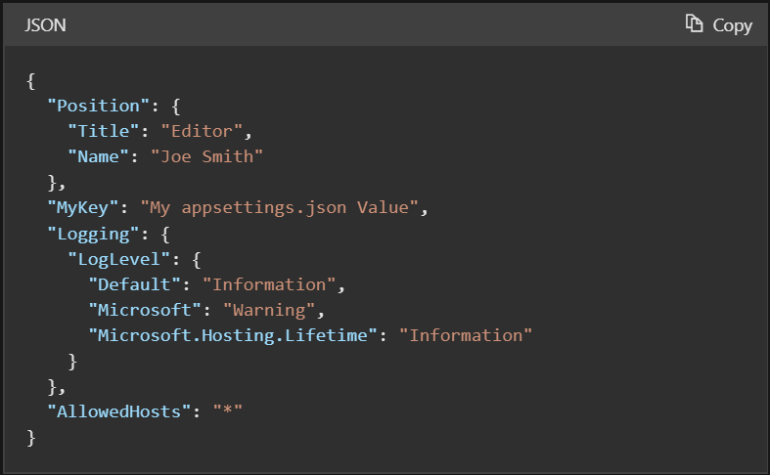

The following code from the sample download displays several of the preceding configurations settings:

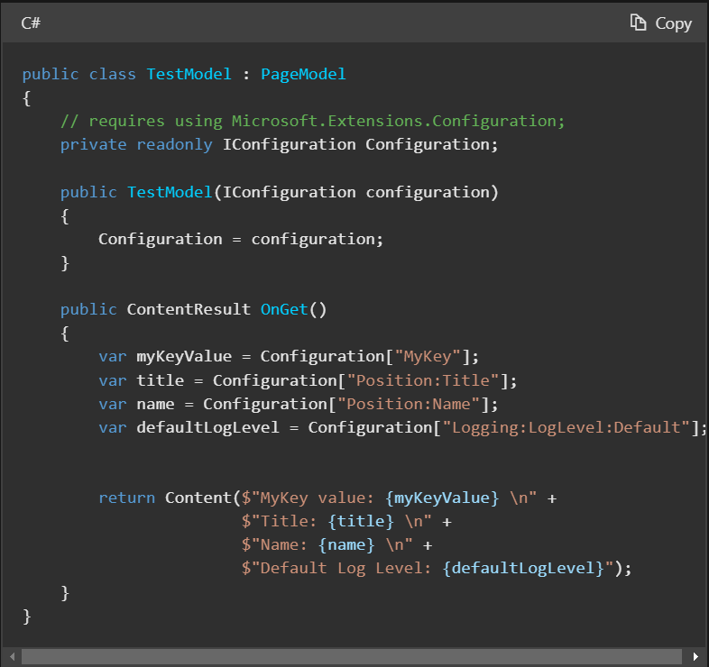
The default JsonConfigurationProvider loads configuration in the following order:
- appsettings.json
- appsettings.{Environment}.json : For example, the appsettings.Production.json and appsettings.Development.json files. The environment version of the file is loaded based on the IHostingEnvironment.EnvironmentName. For more information, see Use multiple environments in ASP.NET Core.
appsettings.{Environment}.json values override keys in appsettings.json. For example, by default:
- In development, appsettings.Development.json configuration overwrites values found in appsettings.json.
- In production, appsettings.Production.json configuration overwrites values found in appsettings.json. For example, when deploying the app to Azure.
If a configuration value must be guaranteed, see GetValue. The preceding example only reads strings and doesn’t support a default value.
Using the default configuration, the appsettings.json and appsettings.{Environment}.json files are enabled with reloadOnChange: true. Changes made to the appsettings.json and appsettings.{Environment}.json file after the app starts are read by the JSON configuration provider.
Comments in appsettings.json
Comments in appsettings.json and appsettings.{Environment}.json files are supported using JavaScript or C# style comments.
Bind hierarchical configuration data using the options pattern
The preferred way to read related configuration values is using the options pattern. For example, to read the following configuration values:
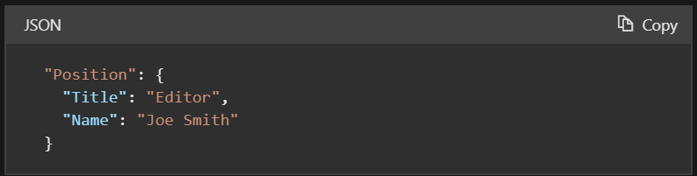
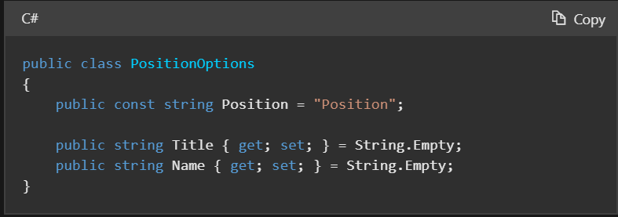
An options class:
- Must be non-abstract with a public parameterless constructor.
- All public read-write properties of the type are bound.
- Fields are not bound. In the preceding code, Position is not bound. The Position field is used so the string "Position" doesn't need to be hard coded in the app when binding the class to a configuration provider.
The following code:
- Calls ConfigurationBinder.Bind to bind the PositionOptions class to the Position section.
- Displays the Position configuration data.
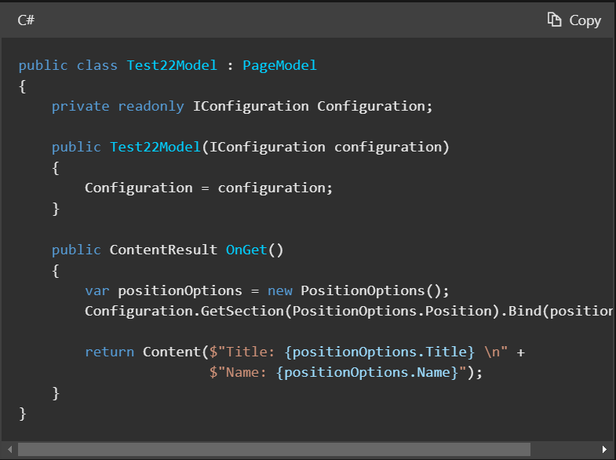
In the preceding code, by default, changes to the JSON configuration file after the app has started are read.
ConfigurationBinder.Get<T> binds and returns the specified type. ConfigurationBinder.Get<T> may be more convenient than using ConfigurationBinder.Bind. The following code shows how to use ConfigurationBinder.Get<T> with the PositionOptions class:
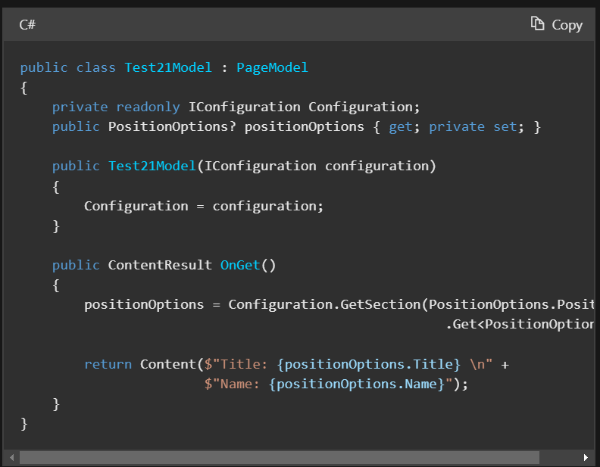
More information about Configuration can be found here https://learn.microsoft.com/en-us/aspnet/core/fundamentals/configuration/?view=aspnetcore-8.0

Exceptions Handlings

This article covers common approaches to handling errors in ASP.NET Core web apps. See also Handle errors in ASP.NET Core web APIs and Handle errors in Minimal API apps.
Developer exception page
The Developer Exception Page displays detailed information about unhandled request exceptions. ASP.NET Core apps enable the developer exception page by default when both:
- Running in the Development environment.
- App created with the current templates, that is, using WebApplication.CreateBuilder. Apps created using the WebHost.CreateDefaultBuilder must enable the developer exception page by calling app.UseDeveloperExceptionPage in Configure.
The developer exception page runs early in the middleware pipeline, so that it can catch unhandled exceptions thrown in middleware that follows.
Detailed exception information shouldn't be displayed publicly when the app runs in the Production environment. For more information on configuring environments, see Use multiple environments in ASP.NET Core.
The Developer Exception Page can include the following information about the exception and the request:
- Stack trace
- Query string parameters, if any
- Cookies, if any
- Headers
The Developer Exception Page isn't guaranteed to provide any information. Use Logging for complete error information.
Exception handler page
To configure a custom error handling page for the Production environment, call UseExceptionHandler. This exception handling middleware:
- Catches and logs unhandled exceptions.
- Re-executes the request in an alternate pipeline using the path indicated. The request isn't re-executed if the response has started. The template-generated code re-executes the request using the /Error path.
Warning
If the alternate pipeline throws an exception of its own, Exception Handling Middleware rethrows the original exception.
Since this middleware can re-execute the request pipeline:
- Middlewares need to handle reentrancy with the same request. This normally means either cleaning up their state after calling _next or caching their processing on the HttpContext to avoid redoing it. When dealing with the request body, this either means buffering or caching the results like the Form reader.
- For the UseExceptionHandler(IApplicationBuilder, String) overload that is used in templates, only the request path is modified, and the route data is cleared. Request data such as headers, method, and items are all reused as-is.
- Scoped services remain the same.
In the following example, UseExceptionHandler adds the exception handling middleware in non-Development environments:
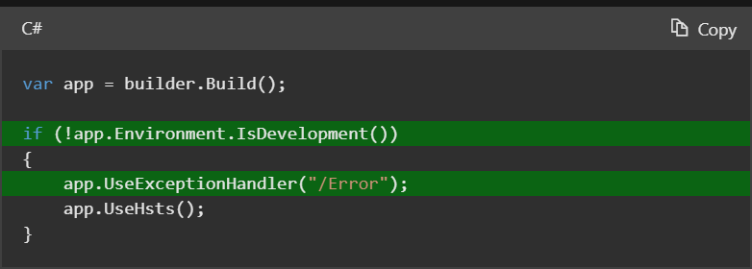
The Razor Pages app template provides an Error page (.cshtml) and PageModel class (ErrorModel) in the Pages folder. For an MVC app, the project template includes an Error action method and an Error view for the Home controller.
The exception handling middleware re-executes the request using the original HTTP method. If an error handler endpoint is restricted to a specific set of HTTP methods, it runs only for those HTTP methods. For example, an MVC controller action that uses the [HttpGet] attribute runs only for GET requests. To ensure that all requests reach the custom error handling page, don't restrict them to a specific set of HTTP methods.
To handle exceptions differently based on the original HTTP method:
- For Razor Pages, create multiple handler methods. For example, use OnGet to handle GET exceptions and use OnPost to handle POST exceptions.
- For MVC, apply HTTP verb attributes to multiple actions. For example, use [HttpGet] to handle GET exceptions and use [HttpPost] to handle POST exceptions.
To allow unauthenticated users to view the custom error handling page, ensure that it supports anonymous access.
Access the exception
Use IExceptionHandlerPathFeature to access the exception and the original request path in an error handler. The following example uses IExceptionHandlerPathFeature to get more information about the exception that was thrown:
Exception handler lambda
An alternative to a custom exception handler page is to provide a lambda to UseExceptionHandler. Using a lambda allows access to the error before returning the response.
The following code uses a lambda for exception handling:
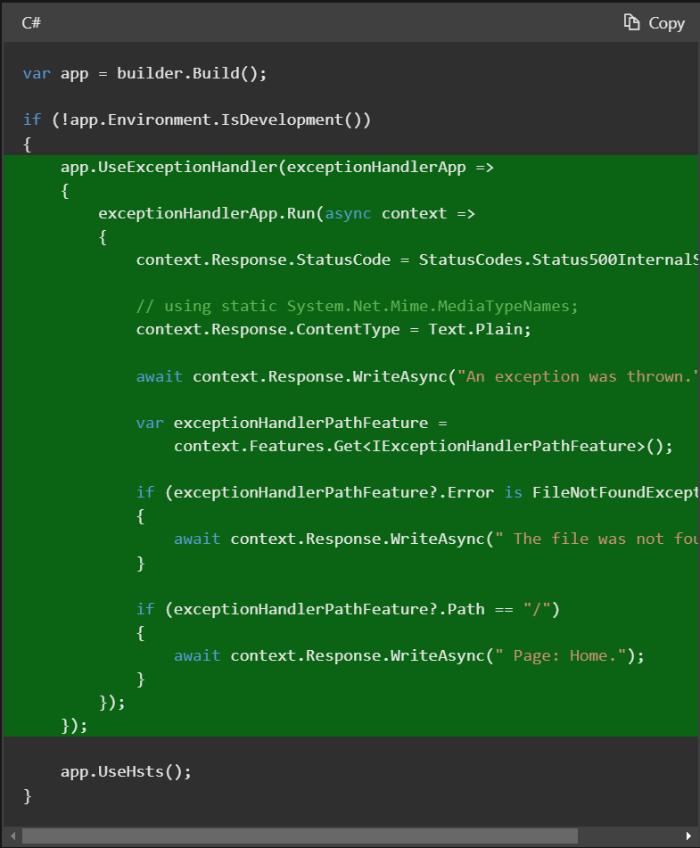
IExceptionHandler
IExceptionHandler is an interface that gives the developer a callback for handling known exceptions in a central location.
IExceptionHandler implementations are registered by calling IServiceCollection.AddExceptionHandler<T>. The lifetime of an IExceptionHandler instance is singleton. Multiple implementations can be added, and they're called in the order registered.
If an exception handler handles a request, it can return true to stop processing. If an exception isn't handled by any exception handler, then control falls back to the default behavior and options from the middleware. Different metrics and logs are emitted for handled versus unhandled exceptions.
The following example shows an IExceptionHandler implementation:
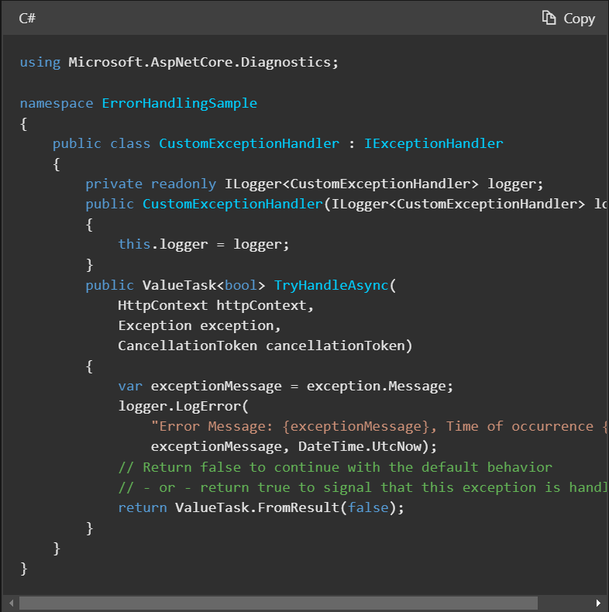
The following example shows how to register an IExceptionHandler implementation for dependency injection:

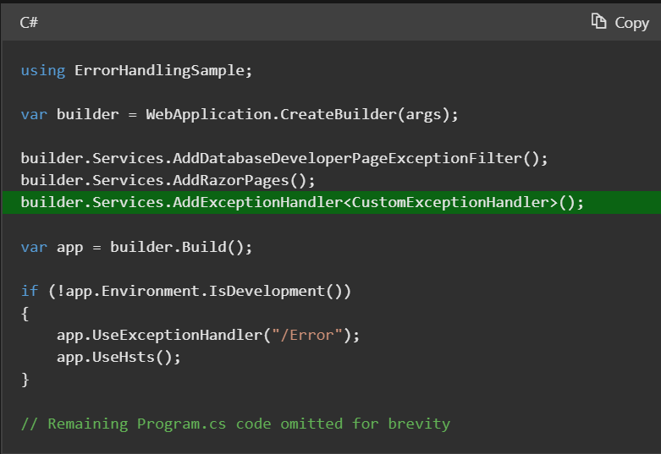

When the preceding code runs in the Development environment:
- The CustomExceptionHandler is called first to handle an exception.
- After logging the exception, the TryHandleException method returns false, so the developer exception page is shown.
In other environments:
- The CustomExceptionHandler is called first to handle an exception.
- After logging the exception, the TryHandleException method returns false, so the /Error page is shown.
More information about Exceptions can be found here https://learn.microsoft.com/en-us/aspnet/core/fundamentals/error-handling?view=aspnetcore-8.0

Results API

ASP.NET Core provides the following options for web API controller action return types:
- Specific type
- IActionResult
- ActionResult<T>
- HttpResults
This article explains when it's most appropriate to use each return type.
Specific type
The most basic action returns a primitive or complex data type, for example, string or a custom object. Consider the following action, which returns a collection of custom Product objects:

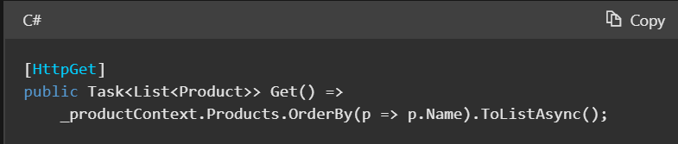

Without known conditions to safeguard against, returning a specific type could suffice. The preceding action accepts no parameters, so parameter constraints validation isn't needed.
When multiple return types are possible, it's common to mix an ActionResult return type with the primitive or complex return type. Either IActionResult or ActionResult<T> are necessary to accommodate this type of action. Several samples of multiple return types are provided in this article.
Return IEnumerable<T> or IAsyncEnumerable<T>
See Return IEnumerable<T> or IAsyncEnumerable<T> for performance considerations.
ASP.NET Core buffers the result of actions that return IEnumerable<T> before writing them to the response. Consider declaring the action signature's return type as IAsyncEnumerable<T> to guarantee asynchronous iteration. Ultimately, the iteration mode is based on the underlying concrete type being returned and the selected formatter affects how the result is processed:
- When using System.Text.Json formatter, MVC relies on the support that System.Text.Json added to stream the result.
- When using Newtonsoft.Json or with XML-based formatters the result is buffered.
Consider the following action, which returns sale-priced product records as IEnumerable<Product>:
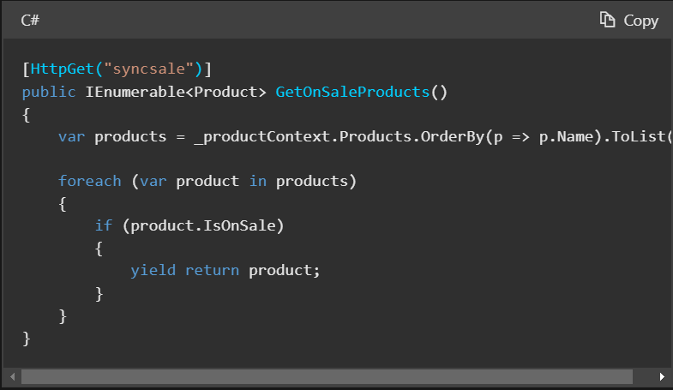

The IAsyncEnumerable<Product> equivalent of the preceding action is:
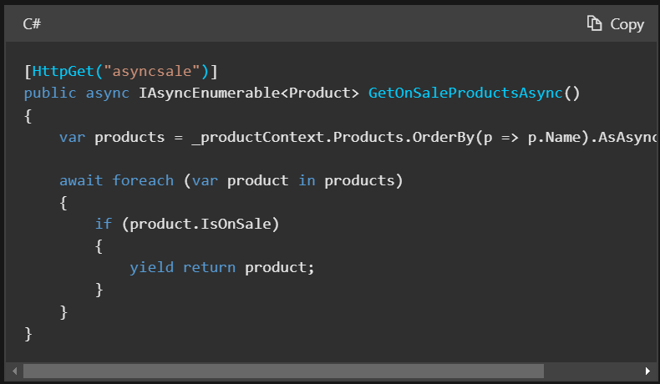
IActionResult type
The IActionResult return type is appropriate when multiple ActionResult return types are possible in an action. The ActionResult types represent various HTTP status codes. Any non-abstract class deriving from ActionResult qualifies as a valid return type. Some common return types in this category are BadRequestResult (400), NotFoundResult (404), and OkObjectResult (200). Alternatively, convenience methods in the ControllerBase class can be used to return ActionResult types from an action. For example, return BadRequest(); is a shorthand form of return new BadRequestResult();.
Because there are multiple return types and paths in this type of action, liberal use of the [ProducesResponseType] attribute is necessary. This attribute produces more descriptive response details for web API help pages generated by tools like Swagger. [ProducesResponseType] indicates the known types and HTTP status codes to be returned by the action.
Synchronous action
Consider the following synchronous action in which there are two possible return types:
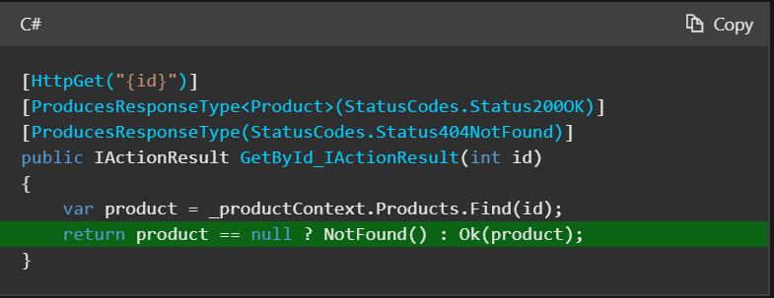
In the preceding action:
- A 404 status code is returned when the product represented by id doesn't exist in the underlying data store. The NotFound convenience method is invoked as shorthand for return new NotFoundResult();.
- A 200 status code is returned with the Product object when the product does exist. The Ok convenience method is invoked as shorthand for return new OkObjectResult(product);.
Asynchronous action
Consider the following asynchronous action in which there are two possible return types:
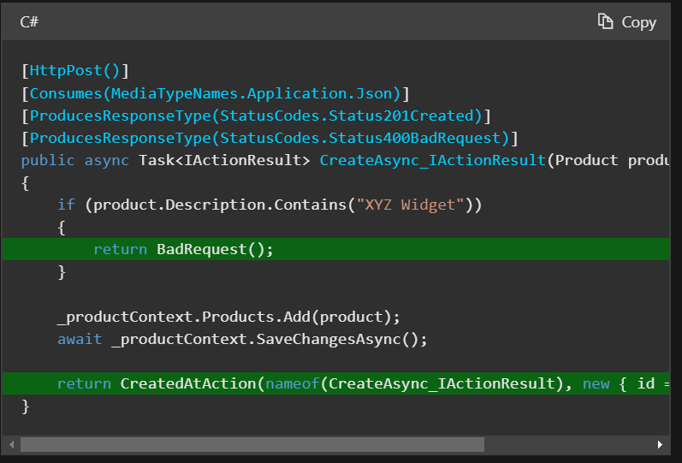
More information can be found here https://learn.microsoft.com/en-us/aspnet/core/web-api/action-return-types?view=aspnetcore-8.0

